SHAHID ALAM 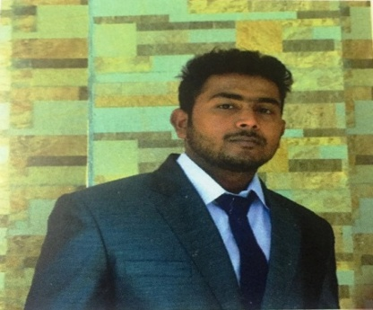
Mobile no. : +91 8876190300
E-mail: shahidalam655@gmail.com
CAREER OBJECTIVE
Seeking a position in the organisation that provides me an opportunity to explore & excel while carving out the niche for personal, professional as well as organizational goals.
COMPUTER KNOWLEDGE
MS Office | - Basic MS EXECL
MS Office | - MS POWERPOINT
MS Office | - MS WORD
COURSE | Basic computer ,Hardware and Software
Platforms Used | Windows XP, Vista,Windows7, Windows8, Windows 10
 | INTERNET SAVVY

ACADEMIC QUALIFICATIONS
Course | Institute | Boards/University | Year of passing | Score
MBA | GAUHATI COMMERCE COLLEGE | GUWAHATI UNIVERSITY | PERSUING | ________
B.COM | ICON COMMERCE COLLEGE | GAUHATI UNIVERSITY | 2014 | 54%
HIGH SECONDARY | SOUTH POINT SCHOOL | CBSE | 2011 | 75%
MATRIC | GAUHATI PUBLIC SCHOOL | CBSE | 2009 | 62%
Personal Description
Nationality Indian
Languages Known Hindi, English, Assamese,
Sex Male
Hobbies Playing pool, travelling to new places, reading novels
Marital Status Unmarried
Date of Birth 15- 08- 1992

PERSONALITY TRAITS
- Strong leadership and motivational skills
- Ability to handle pressure
- Excellent in communication both written and verbal
- Ability to handle team
- Strong problem solving skills to resolve issues quickly and fairly

MBA SUMMER INTERNSHIP

Company Name : YAMAHA MOTOR INDIA SALES PVT. LTD
Two months project on the topic " A Study On The Consumer Decision Making On Purchase And Sale Of Pre- Owned Two Wheelers After The Launching Of Yamaha Bikes Exchange Scheme. "
WORK PROFILE

- Going on field with seniors to study the market and customers of the company
- Generating enquiries for the company and converting them to customers
- Studying the market and the company products as compared to others company
- Assisting seniors in daily activities
WORK EXPERIENCE : FRESHERS

DECLARATION

I consider myself familiar with management aspects . I am also confident of my ability to work sincerely as a team-member.
I hereby declare that the particulars furnished above are true, complete and correct to my knowledge and belief.

DATE:

PLACE: (SHAHID ALAM)

